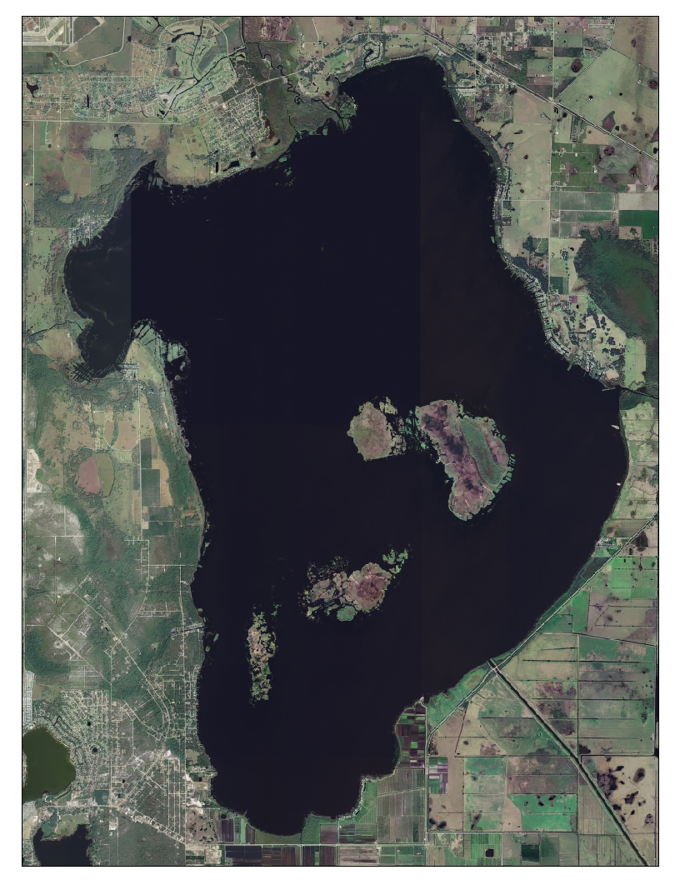

Torpedo grass treatment areas that will be conducted December 2008. Approximately 200 acres will be targeted for treatment within the areas identified in yellow.

